Chapter 2, Solution 59

Three light bulbs are connected in series to a 120-V source as shown in Fig. 2.123. Find the current I through each of the bulbs. Each bulb is rated at 120 volts. How much power is each bulb absorbing? Do they generate much light?
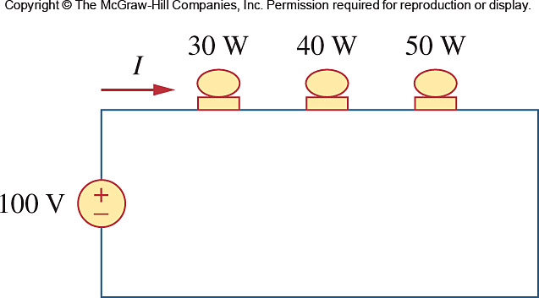

120 V

Figure 2.123
For Prob. 2.59.

Solution

Using p = v²/R, we can calculate the resistance of each bulb.

R_{30W} = (120)²/30 = 14,400/30 = 480 Ω

R_{40W} = (120)²/40 = 14,400/40 = 360 Ω

R_{50W} = (120)²/50 = 14,400/50 = 288 Ω

The total resistance of the three bulbs in series is 480+360+288 = 1128 Ω.

The current flowing through each bulb is 120/1128 = 0.10638 A.

p₃₀ = (0.10638)²480 = 0.011317x480 = 5.432 W.

p₄₀ = (0.10638)²360 = 0.011317x360 = 4.074 W.

p₅₀ = (0.10638)²288 = 0.011317x288 = 3.259 W.

Clearly these values are well below the rated powers of each light bulb so we would not expect very much light from any of them. To work properly, they need to be connected in parallel.

